**ChinaNANO 2025 Registration Guide**

Visit the Official Website, go to http://www.chinanano.org.cn/en/ to access the official ChinaNANO 2025 English website.



At the bottom of the homepage, click “Registration” to proceed to the login/registration portal.

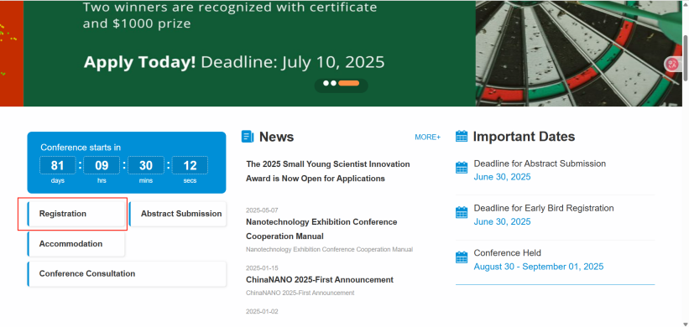

Once logged in, you will be able to:

* Register for the conference and complete payment
* Submit your abstract
* Reserve accommodation

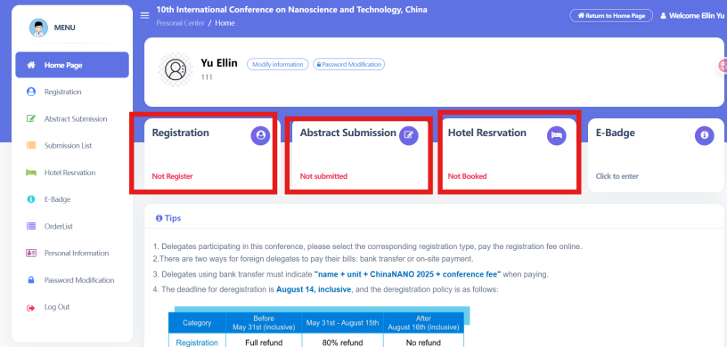

**Conference Registration & Payment**

Click “Registration”,

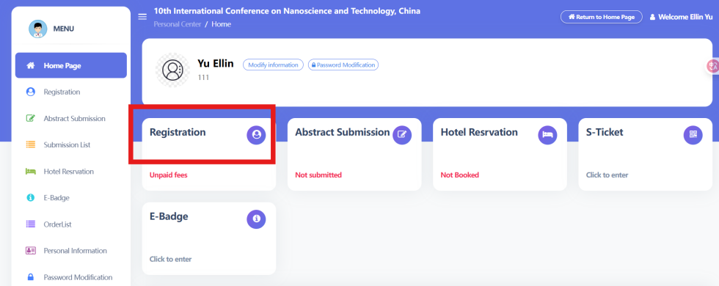

Select your registration type.

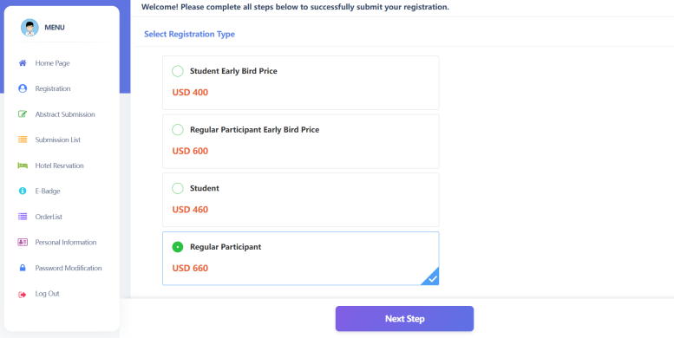

Once all information is confirmed, click “Next Step” to finalize your registration and proceed with payment

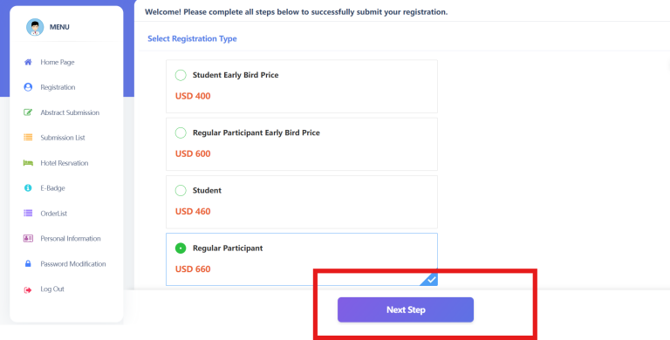

After confirming your registration type and fee, click "Yes".

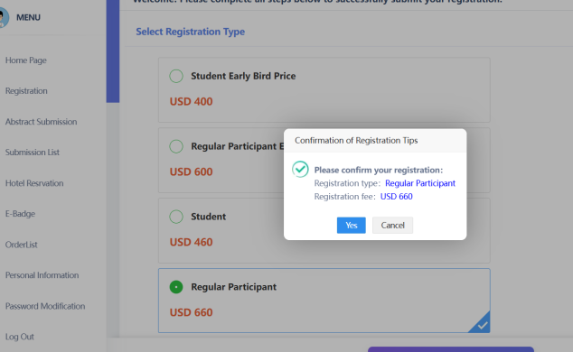

After verifying your registration information and confirming its accuracy, click "Next Step" to proceed with the registration fee payment via Online Pay.

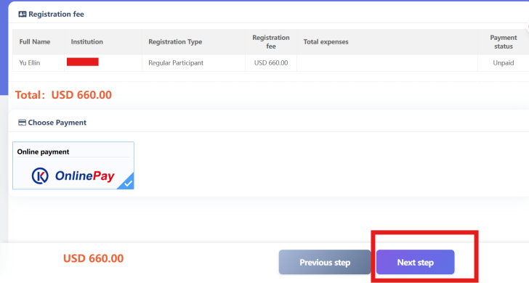

Click “Confirm Payment”

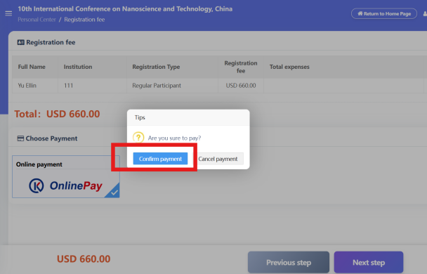

Fill Card Information and Billing Information

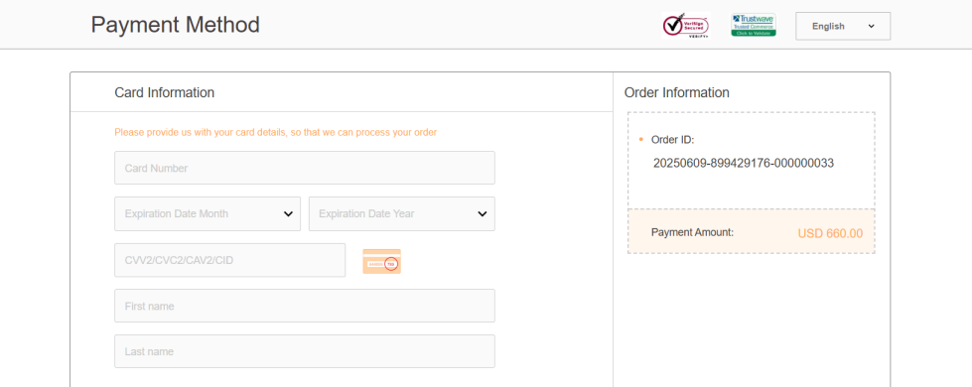

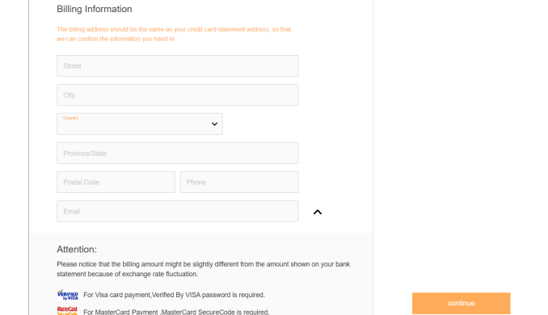

After completing the two forms, click “Continue” to proceed with payment.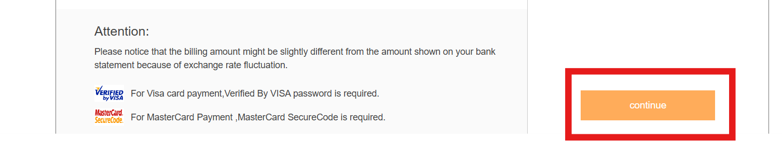

**Abstract Submission**

Click “Abstract Submission”,

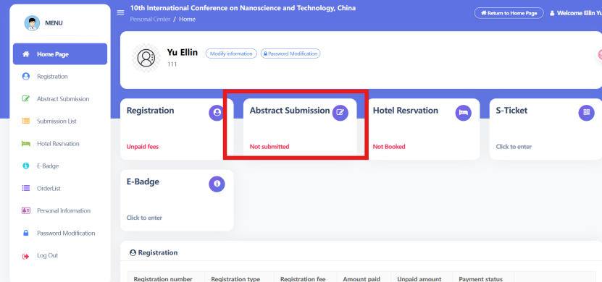

On the submission page, click “Start contributing”,

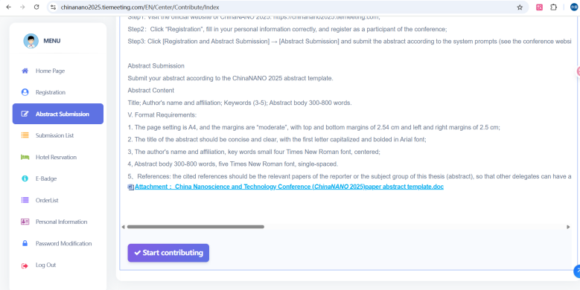

Fill in the required author information and click **“Fill in information of the author”.**

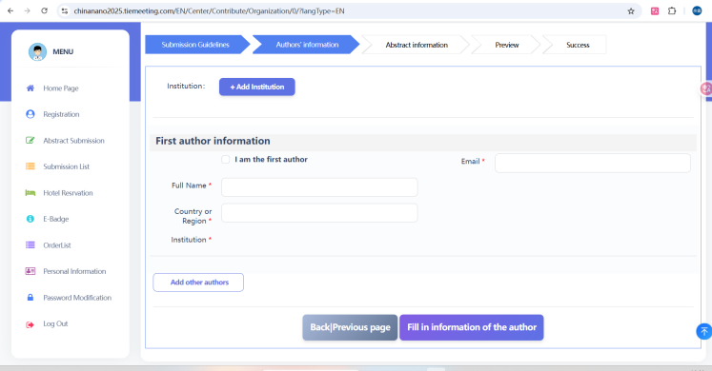

On the manuscript submission page, provide the following:

* Presenting Type
* Session topic (sub-forum)
* Title of the Paper
* Abstract Content
* Keywords  
  Then **upload your abstract file** and click “Next|Review Submission”.

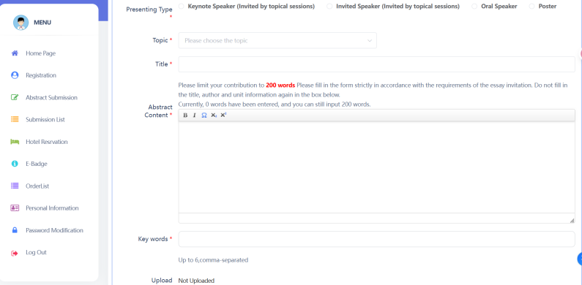

Review your submission, then click “Next|Complete Submission”. Your abstract has now been submitted successfully.

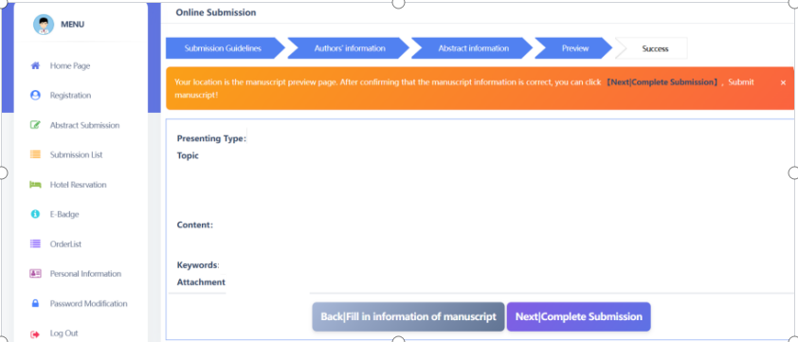

**Accomodation**

Click “Hotel Reservation”.

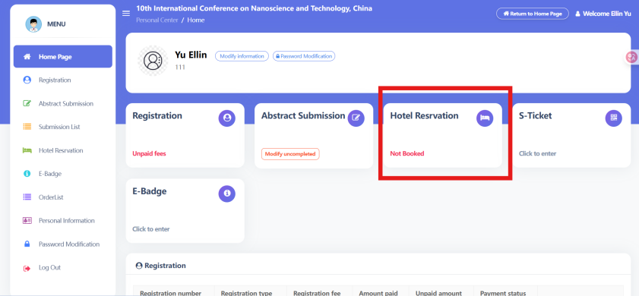

On the hotel booking page, select your preferred hotel and room type.

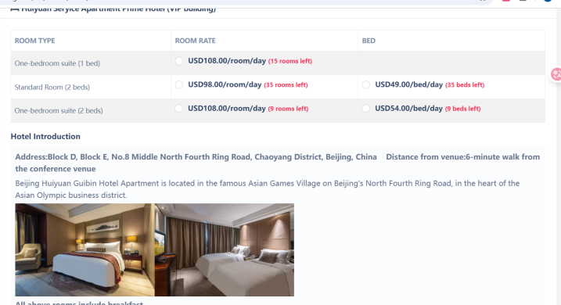

Enter your check-in and check-out dates, then click “Confirm”.

